Lab 3: Image Processing

Name: AAAAAAAAAAAA Student ID: 0000000000000

**[ Please delete these red sentences and my example answers for Question 1 from your submission. The examples are provided for reference only—you do not need to follow every detail. Just make sure to include all required answers. ]**

1. Histogram equalization
2. Compute and visualize histogram and cumulative distance function (CDF) of an input gray-scale image

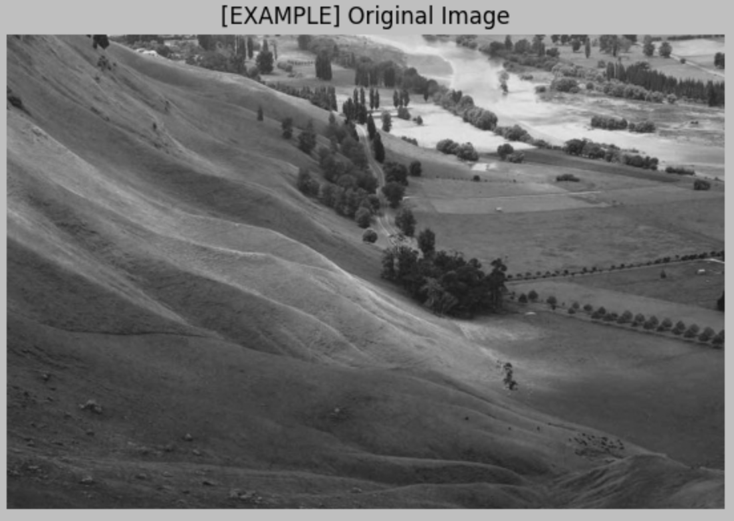

1. Apply histogram equalization using obtained CDF on the input image

1. Compute and visualize histogram of output image

1. Image denoising
2. Read the input image and convert to a grayscale image
3. Add two types of noise including Gaussian noise and Salt/Pepper noise (Implement your own functions to add noise to an image)
4. Implement mean and median filtering in 5x5 windows
5. Check if mean or median filtering is able to completely remove Gaussian noise or Salt/Pepper noise. Compare original image and denoised image.
6. Image gradient
7. Compute image gradient in x and y direction respectively
8. Read the input image and convert to a grayscale image
9. Compute magnitude of image gradient for each pixel
10. Thresholding on magnitude to determine image edges, try various thresholds.
11. Code screenshots